**New Jersey's Good Samaritan and Hold Harmless Law**

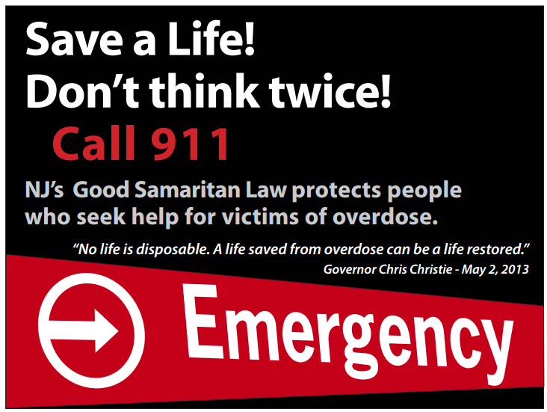

New Jersey's Good Samaritan and Hold Harmless Law protect people who seek help for victims of overdose or alcohol poisoning.

If you suspect someone is overdosing from illegal drugs, prescription drugs or alcohol, call emergency or medical personnel immediately.

Stay on the phone with the 911 operator and wait until the emergency services arrive. Do not leave the person unattended.  
The Scotch Plains-Fanwood Public School District does not advocate or encourage the underage consumption of alcohol, the use of illegal drugs, or abuse of prescription drugs. If you have any questions, please contact your local police department.

Scotch Plains Police Department   (908)322-7100

Fanwood Police Department    (908)322-5000